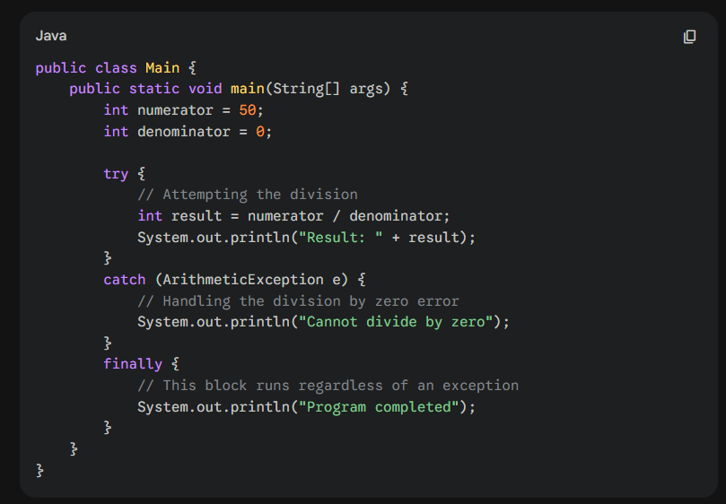
finally block is used for guaranteed execution in scenarios where a simple print statement might be skipped. Here are the three main reasons why finally is used in professional Java development:

1. Handling Uncaught Exceptions
If your code throws an exception that you did not specify in a catch block (for example, a NullPointerException when you were only looking for an ArithmeticException), the program will crash.
- Without finally: Any code after the try-catch will never run.
- With finally: The code inside finally runs before the program crashes, allowing you to save data or close connections.

2. The "Return" Statement Challenge
In Java methods, if you return a value inside a try or catch block, the method ends immediately.
- Code written after the blocks will be ignored.
- Code inside the finally block will still execute even after the return command is issued.

3. Resource Cleanup (The Primary Use Case)
The most important use of finally is "cleaning up." When you open a file, a database connection, or a network socket, these take up system memory. If an error occurs and you don't close them, you get a memory leak.

